Assignment Cover Sheet

 | Qualification |  |  | Module Number and Title
 | HD in Computing and Software Engineering /Network Technology and Cyber Security |  |  | CSE 4002  Fundamentals in Programming
 | Student Name & No. |  |  | Assessor
 | M.N.M.Dilshad  CL/HDCSE/CMU/112/32 |  |  | Mr.Deshan
 | Hand over date |  |  |  | Submission Date
 | Assessment type |  | Duration/Length of  Assessment Type |  | Weighting of Assessment
 | Coursework |  | Software Submission and demonstration |  | 100%
Learner declaration
I, ………………………………………….<name of the student and registration number>, certify that the work submitted for this assignment is my own and research sources are fully acknowledged.
M.N.M.Dilshad CL/HDCSE/CMU/112/32
Marks Awarded
First assessor
IV marks
Agreed grade
Signature of the assessor |  | Date

Feedback Form
International College of Business & Technology

Module : CSE 4002
Student : M.N.M.Dilshad CL/HDCSE/CMU/112/32
Assessor : Mr.Deshan
Assignment : Amber bakery automated billing system
Assessor Feedback:

Marks Awarded:

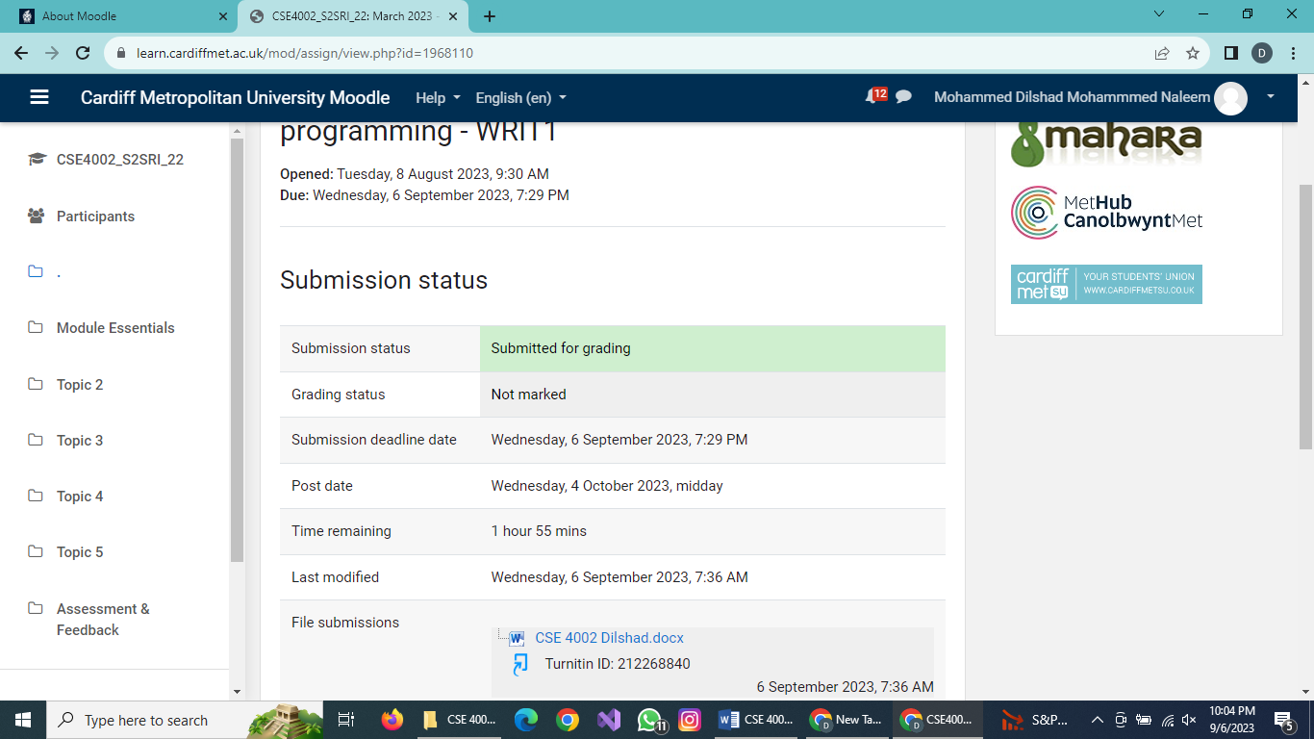

Amber Bakery System
Software Requirements Specification
(SRS)
Version 1.0 Approved
06th September 2023.

Prepared by M.N.M,Dilshad.

Prepared for CSE 4002
Fundamentals in Programming

Abstract

The software requirement specification (SRS) for the suggested software solution for the Amber bakery seeks to deliver comprehensive system that streamlines the bakery operations and tackles the difficulties the marketing and bakery departments confront. User software system user friendly design, additionally the system will have tools for manage bakery items, add new bakery item , add new customers , and some others for a better decision making it should also enable numerous users and produce real time data reports performances, security, reliability and maintainability are just a few of the non-functional needs that will be taken into account while the system is designed , it is anticipated that the suggested software solution will increase staff productivity. Lighten the workload, and boost customer happiness through greater support. After the Implementation.

Introduction for C ++

Both technically inclined individuals with little to no programming experience and seasoned programmers can use the potent computer programming language C++ to build complex information systems. You are already aware of the amazing tasks that machines can perform. Currently, mastering object-oriented programming is the most crucial computer skill. One of the most widely used programming languages nowadays is C++.
There are currently more mobile, cell, and portable devices in use than general-purpose computers, which number over a billion.
High-performance apps can be made using the cross-platform programming language C++. Bjarne Stroustrup created C++ as an expansion of the C language. Programmers now have a lot of control over the system and memory thanks to C++.

Contents.
- SYSTEM REQUIREMENTS SPECIFICATION.
  - Introduction. 4
  - Purpose. 4
  - Project Scope. 4

1.2 General Description.
1.2.1 Product Perspective. 4
1.2.2 Product Functions. 5
1.2.3 Assumption and Dependencies. 5
1.3 Functional Requirements. 5
1.4 Non – Functional Requirements. 6
1.5 Modularization. 7
1.6 Clarity and Complex Reduction. 7
1.7 Data Requirements. 7
1.8 External Interface Requirements. 8
1.9 Analysis Models. 9
1.9.2 Pseudo Code.
2. IMPLEMENTATION OF THE SYSTEM C++ (TASK 2)
2.1 Libraries. 19
2.2 Void Functions. 20
2.3 Structures.
2.4 Main function. 20
2.5 Void companydetails(). 21
2.6 Void exitsystem() 22
2.7 Void login() 23
2.8 Void admindash() 25
2.9 Void managebakeryitem() 27
3. TEST PLAN AND USER ACCEPTANCE TESTNG (TASK-03)
3.1 Test Plan 30
3.2 Test Cases. 34
4. Suggestion. 41
5. Conclusion. 41
6. References. 41

.
  - Introduction
The Amber Bakery System offers mouthwatering bakery goods to both domestic and international customers. The bakery has seen a large rise in consumer queries regarding newly arriving things as a result of the launch of new items like cakes and beverages that are evolving with soft skills. However, due to a lack of capacity in the marketing and staff administration departments, the performance of the bakery has dropped, and customers are unhappy as a result of the poor service. To fix this issue, the operations of the bakery must be optimized utilizing a comprehensive software solution.
1.1.2 Project Scope.
The following functions will be provided by the system :
- Staff /Admin Login - Login system
- Staff/Admin Logout – Logout system.
- View Available Bakery items – Display a list of bakery items.
- Manage bakery Details – Manage bakery details or information.
- Manage User Staff Details.
- View Bakery Details – Display company details.
- Exit – Exit and Return to the system.

  - General Description

    - Product Perspective.
The suggested software system will be developed using techniques and tools that are widely used in the field. It will be built modularly for ease of maintenance and scalability. An intuitive user interface will be built into the system, making it feasible for customers and administrators to access its features with ease.
    - Product Functions.
Management of bakery items should be possible through the system.
User Management: The system should provide management of bakery goods by both the admin and user.
Security: To maintain the security and privacy of sensitive information, the system should offer secure login authentication, role-based access control, and data encryption.
User Interface: The system should have a user-friendly, responsive, and intuitive user interface.

    - Assumptions and Dependencies.

• The Amber bakery is deemed to have an acceptable number of personnel who are trained to operate the suggested software system efficiently.

• It is assumed that the Amber bakery will make accessible the essential documentation and data for the construction and deployment of the software system. • The suggested software system is reliant on the availability of hardware and software that satisfy the minimal criteria of the system.

• The suggested software solution must be connected with Amber Bakery's existing systems and databases for information about the bakery, users, and personnel.

  - Functional Requirements
The following are the functional requirements performed by Amber bakery system. Here are the functional requirements.

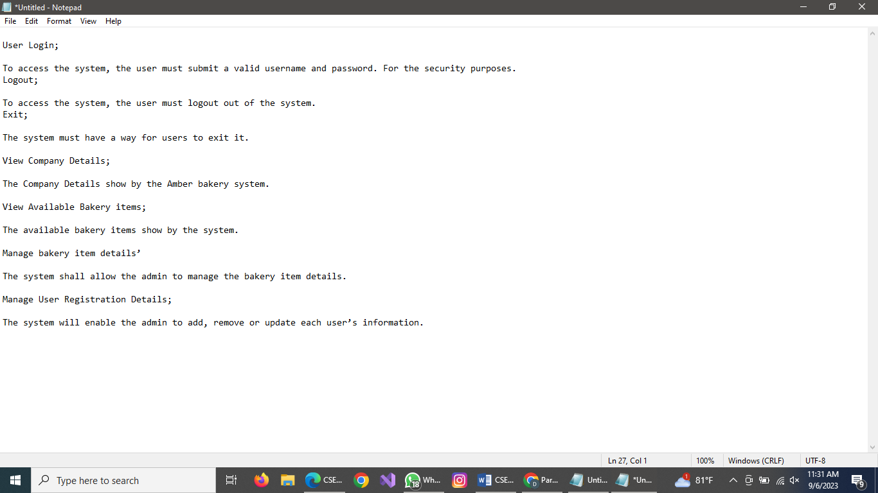

1.6 Non – Functional Requirements.
Here are many non – functional – requirements such as Performance, Reliability, Security,
Maintainability and Availability.

Now let us consider one by one.
- Performance
Without losing responsiveness or performance, the system must be able to handle a large number of concurrent users and data processing requirements.

- Reliability
The system should be exceptionally dependable with little downtime for repairs and updates.

- Security

User data must be protected from unwanted access, and the system must ensure this.

- Maintainability
The system should be built in modules and have a minimal, manageable codebase that is easy to add to.
- Availability
The system must be accessible at all times, excepting maintenance windows.

  - Modularization
Modularization is critical for the proposed software architecture for the Amber Bakery system. The system will be built using a modular approach to design in order to allow easy maintenance and scalability. The program will be divided into modules, each of which will represent a different component or operation of the system, such as bakery management, employee management, and bakery item management.

  - Clarity and Complexity Reduction
The system's design must promote simplicity and clarity. The user interface needs to be clear and uncomplicated. The system must avoid introducing complexity that is not required, such as complicated algorithms or voluminous data input.

  - Data Requirements
User information: Store the following information about each user.
- Name.
- Address.
- Phone number.
- Selected bakery item

Bakery Information: Store the following information about courses.
- Item code.
- Item name.
- Price.

  - External Interface Requirements.
Hardware Interfaces
Recommend using the following hardware requirements:
- Processor: Intel Core i5 or higher.
- RAM: 8 GB or higher.
- Hard disk: 500 GB SSD or higher.
- Internet Connection: Broadband Internet connection (Recommend SLT Fiber)
- Drives: Keyboard, Mouse, Printer.

Software Interfaces.
As a starting point, suggest using a Windows 10 with Visual Studio 2022.

  - Analysis Models.
1.9.1 Pseudocode

1.9.2. Pseudo Codes

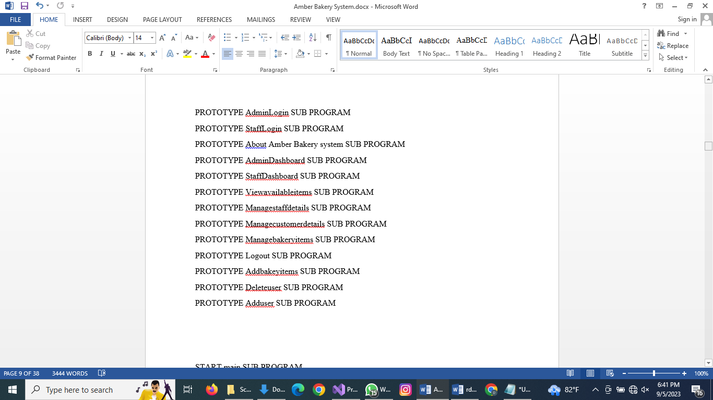

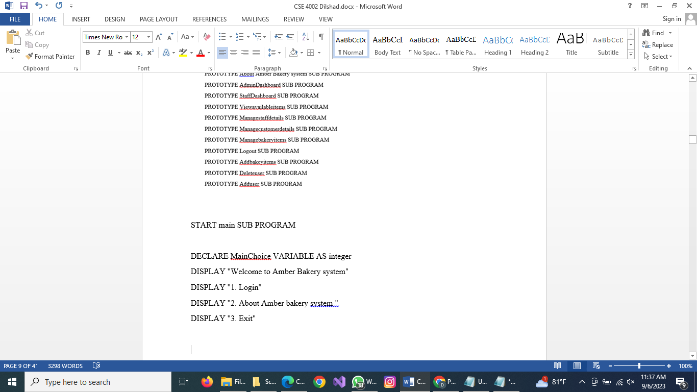

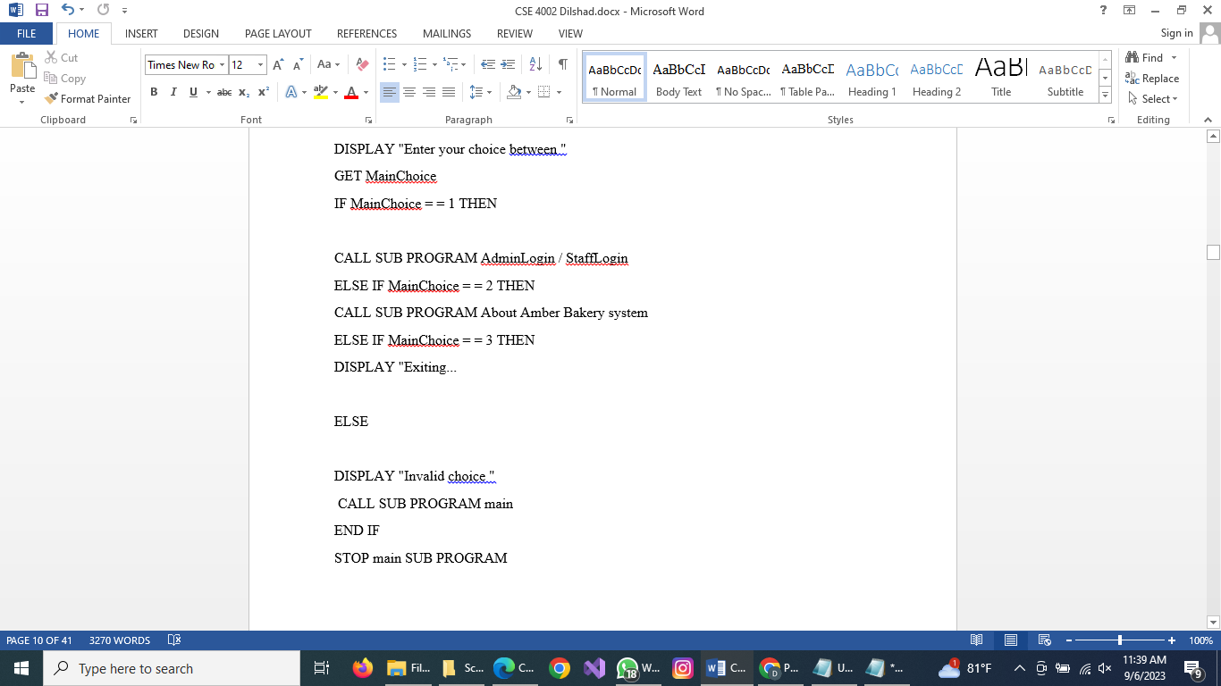

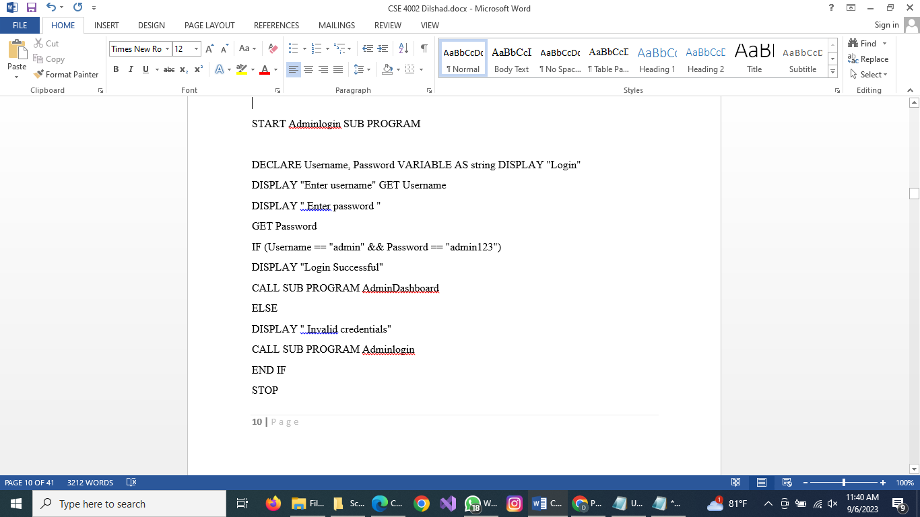

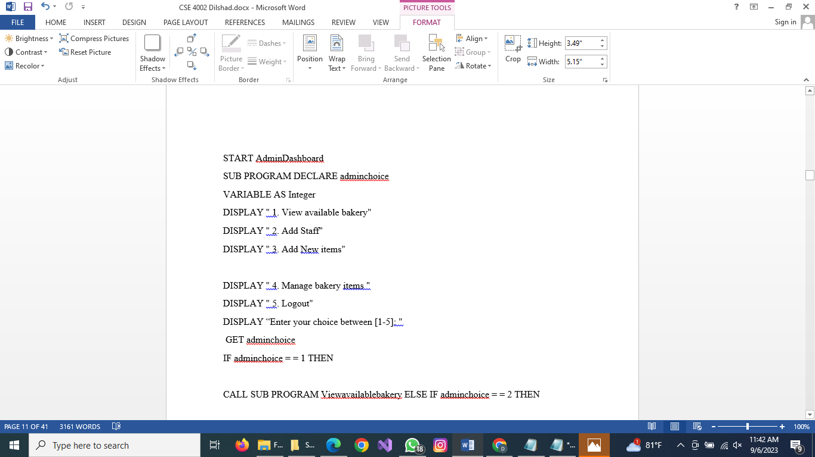

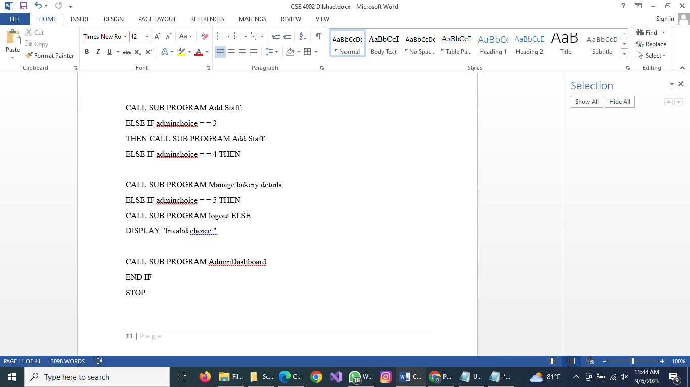

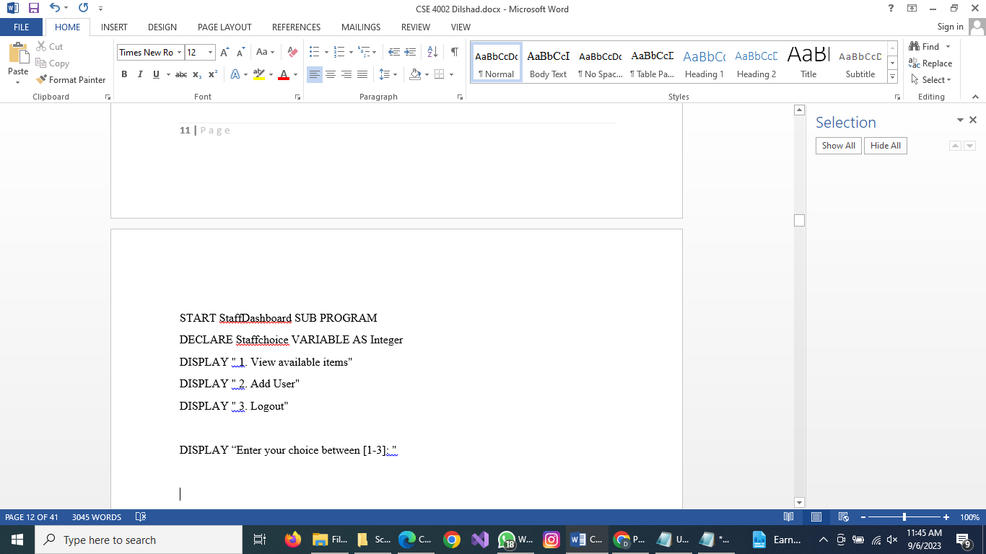

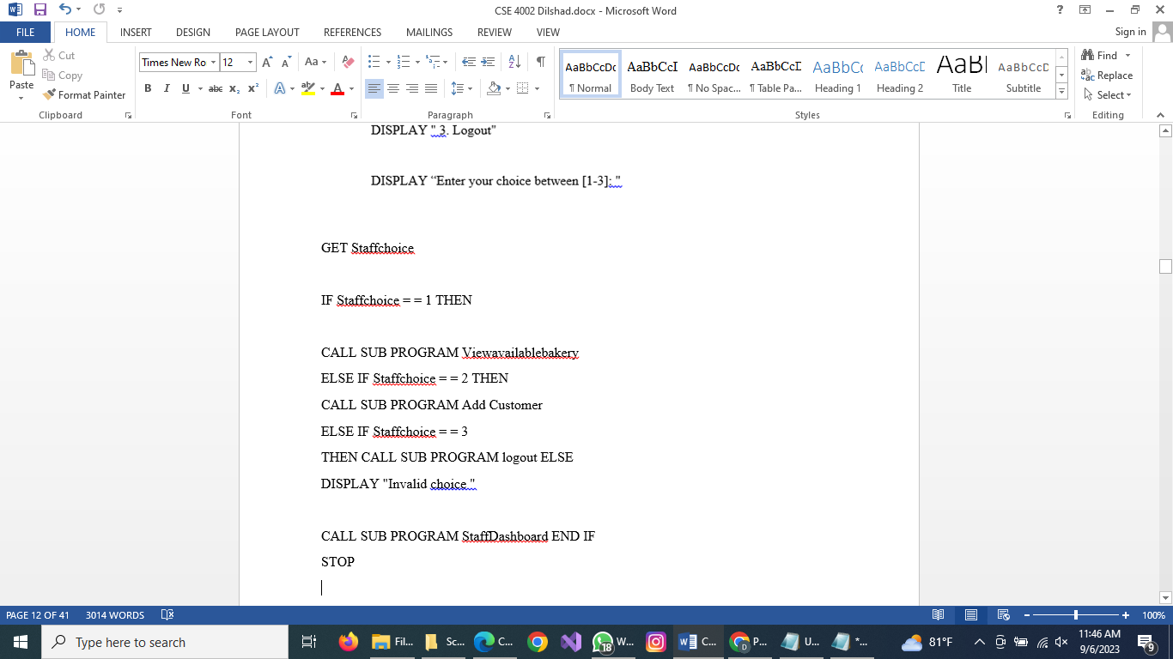

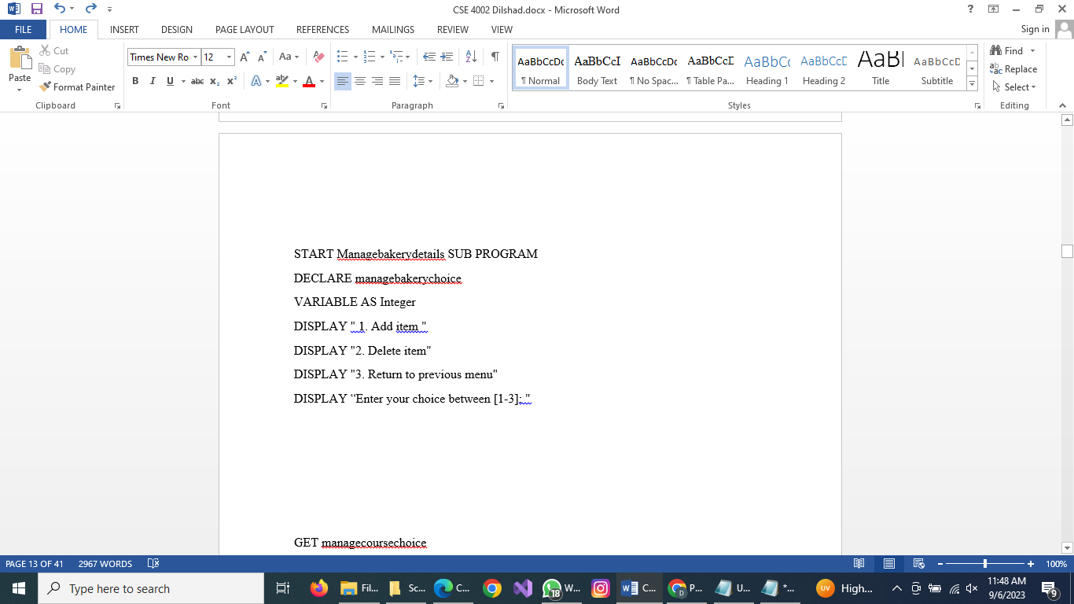

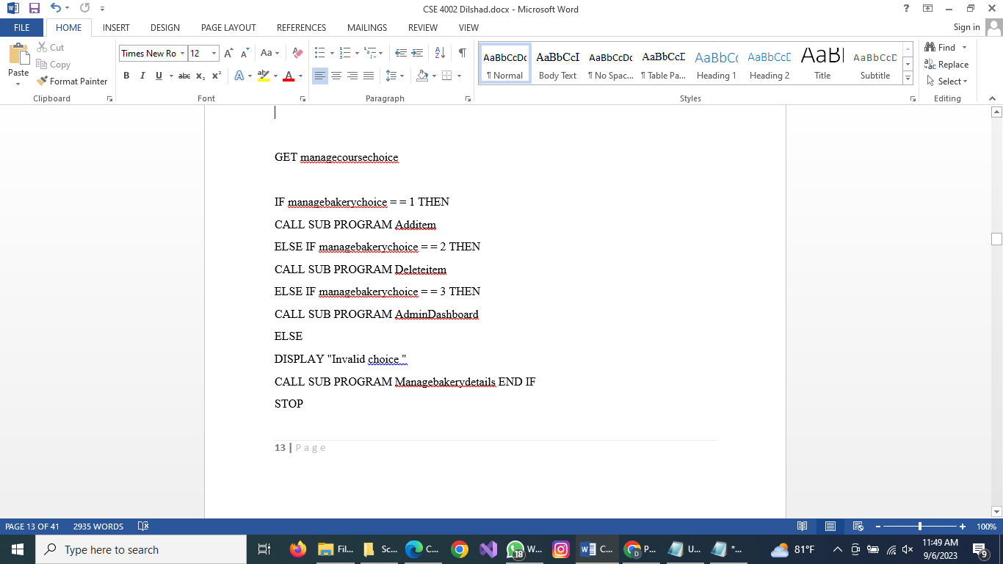

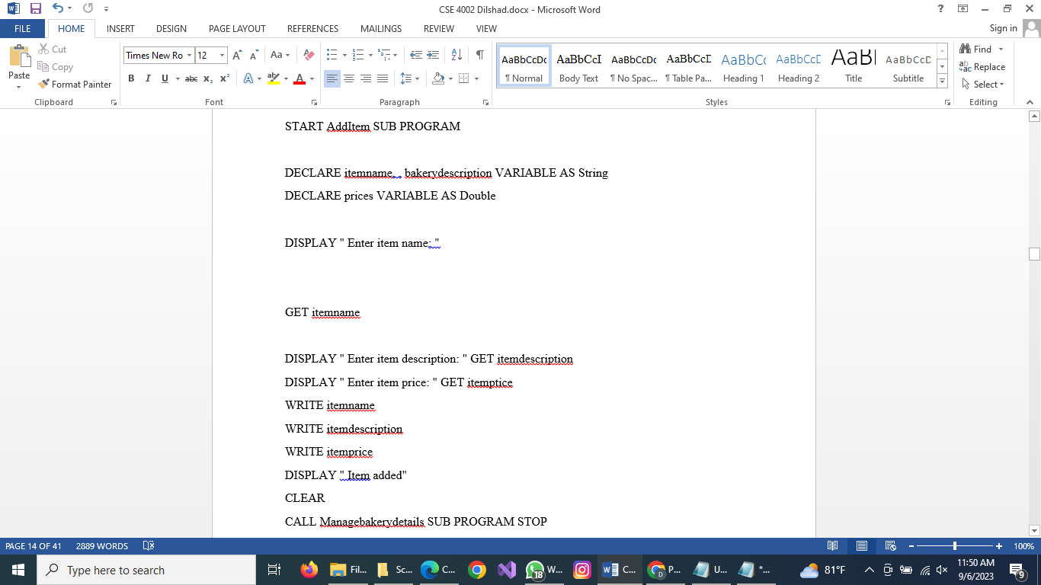

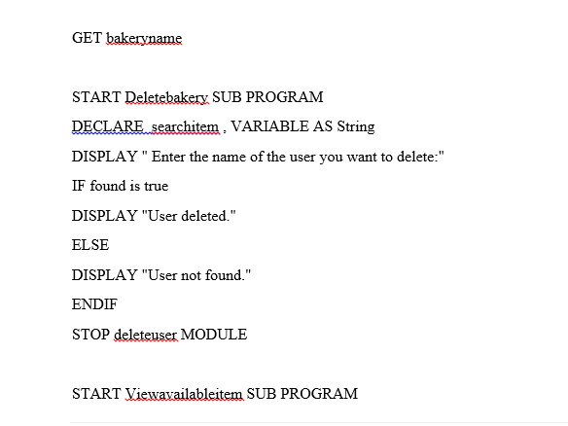

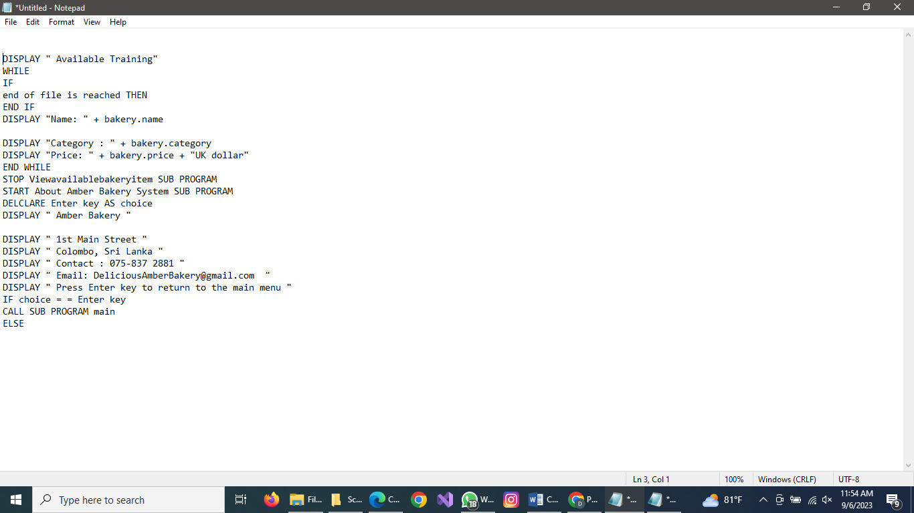

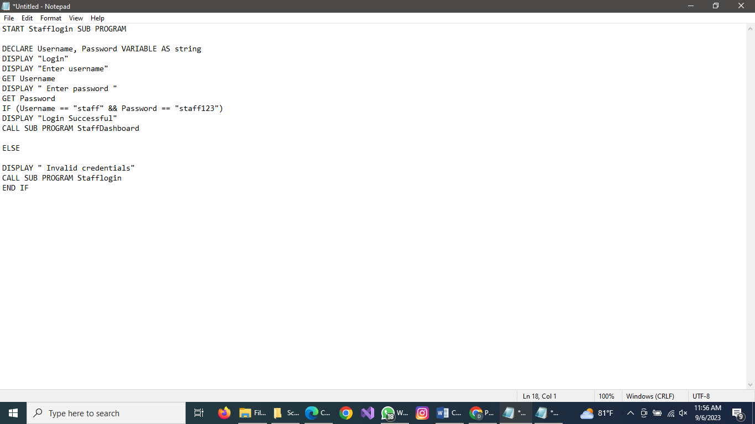

STOP

START AdminDashboard SUB PROGRAM
DECLARE adminchoice VARIABLE AS Integer
DISPLAY " 1. View avalable bakery Items"
DISPLAY " 2. Add bakery item"
DISPLAY " 3. Add user"

DISPLAY " 4. Manage bakery details"
DISPLAY " 5. Logout"
DISPLAY “Enter your choice between [1-5]:
GET adminchoice
IF adminchoice = = 1 THEN

CALL SUB PROGRAM Viewavailableitems
ELSE IF adminchoice = = 2 THEN
CALL SUB PROGRAM Add Student
ELSE IF adminchoice = = 3 THEN
CALL SUB PROGRAM Add Staff
ELSE IF adminchoice = = 4 THEN

CALL SUB PROGRAM Manage bakery details ELSE IF adminchoice = = 5 THEN
CALL SUB PROGRAM logout ELSE
DISPLAY "Invalid choice "

CALL SUB PROGRAM AdminDashboard END IF
STOP.

START StaffDashboard
SUB PROGRAM DECLARE Staffchoice
VARIABLE AS Integer DISPLAY " 1. View available bakery item "
DISPLAY " 2. User Student"
DISPLAY " 3. Logout"

DISPLAY “Enter your choice between [1-3]: "

GET Staffchoice

IF Staffchoice = = 1 THEN

CALL SUB PROGRAM Viewavailableitems
ELSE IF Staffchoice = = 2 THEN
CALL SUB PROGRAM Add Student
ELSE IF Staffchoice = = 3
THEN CALL SUB PROGRAM
logout ELSE
DISPLAY "Invalid choice "

CALL SUB PROGRAM StaffDashboard END IF
STOP

- IMPLEMENTATION OF THE SYSTEM C ++ (TASK-2)

  - Libraries.

- #Include <iosstream> : This library contains functionality for reading and writing and also input/output stream library to the empty.
- #include <string> : This library allows us for working with string data.
- #include <fstream> : This library allows us for maling with files and input/output.
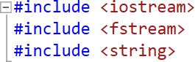

The namespaces std; (Standard) is used in the declarative section where the scope of identifiers such as functions, the names of classes, types , variables , and so on is decleared.

  - Void Function
The void functions specify that doesn’t return a value
(Avoid garbage Values).
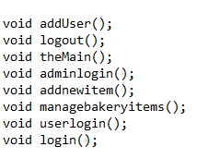

  - Structures.

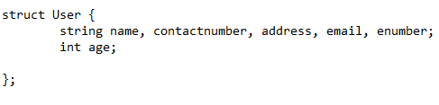

The structure is a collection of different data types and different types of data.

  - Main function
The main function is knows as the main menu. It directs the user to three different interfaces such login, About Amber bakery and exit.
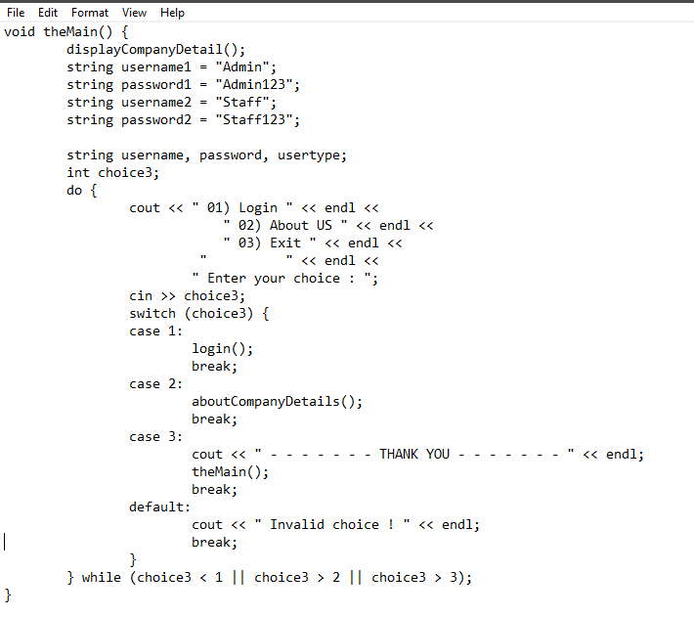

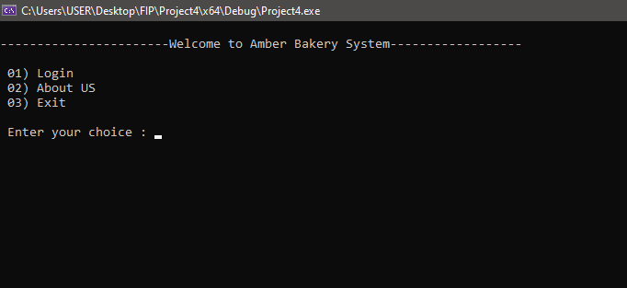
Output :

  - Void companydetails()

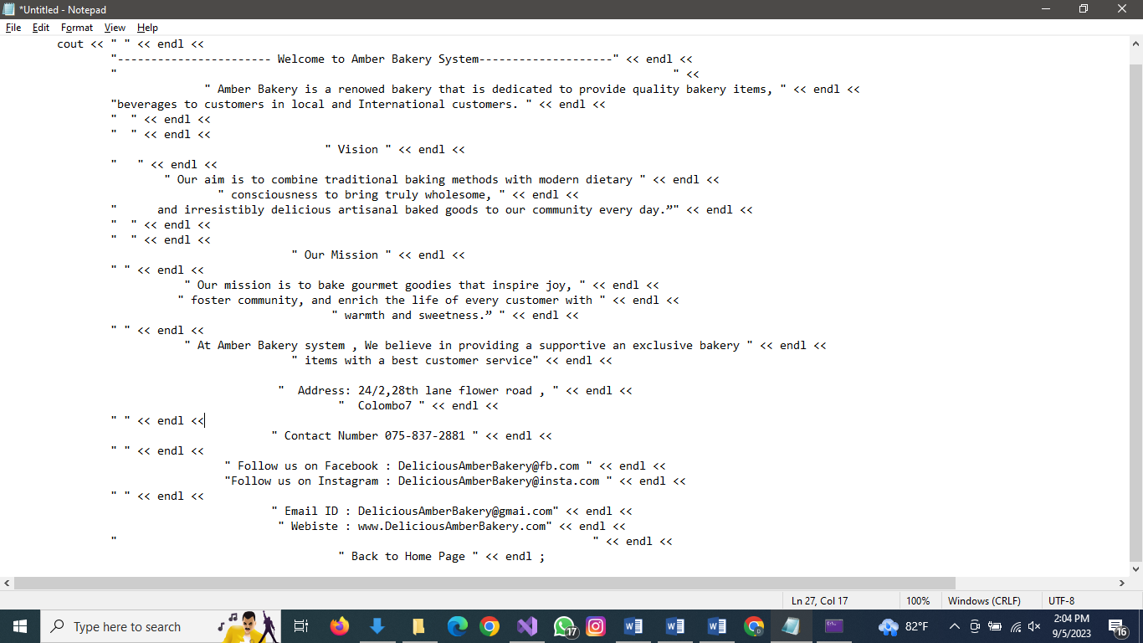

Output:
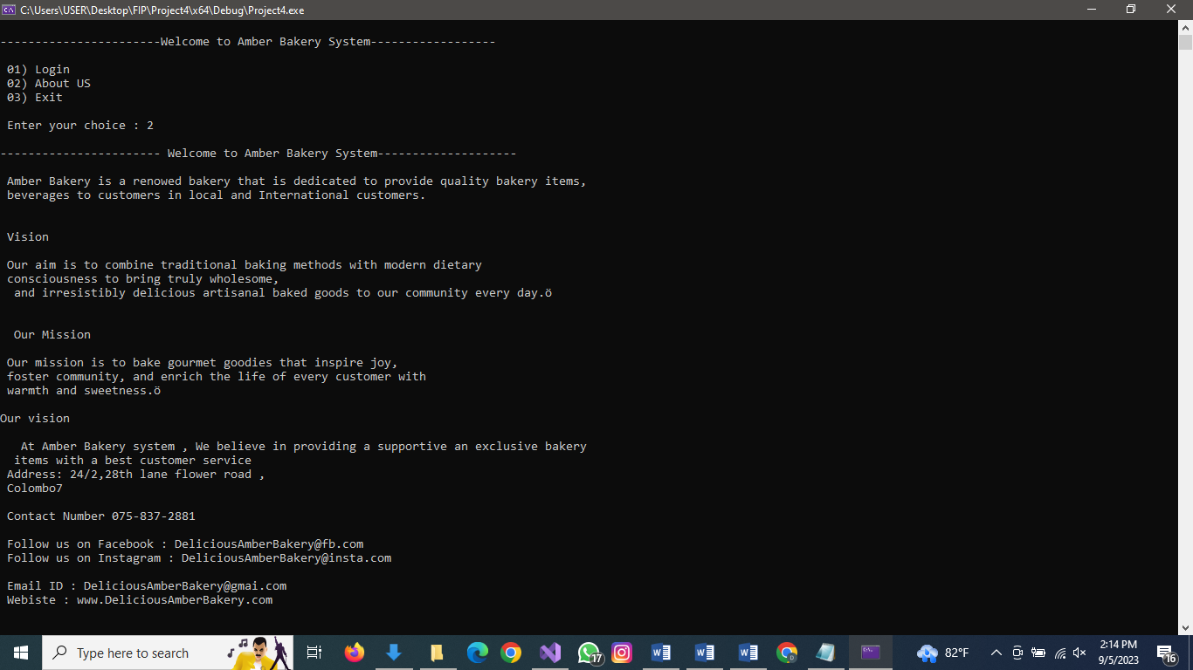

  - Void exitsystem()
This exitsystem()When the user chooses to end the program, a message is displayed to them along with the cout command.
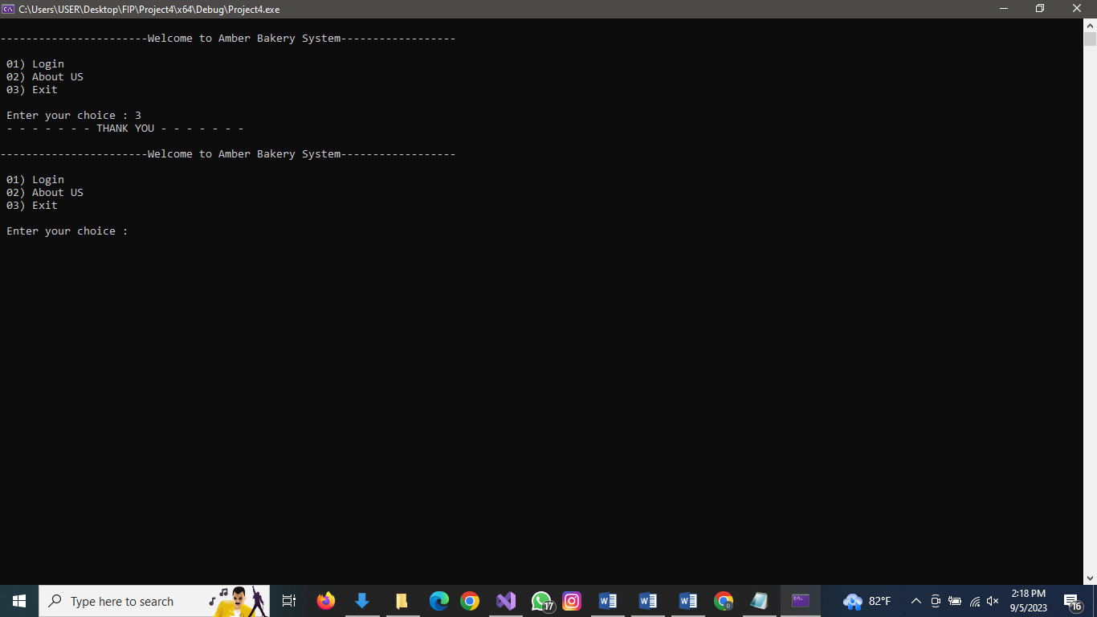

  - Void Login()
The adminlogin() or stafflogin() functions are implemented to allow access. This function begins by deleting the usertype username and password string variable. Using the cin function, it reads the input and puts it in the appropriate variables. Then it determines if the usertype, username, and password entered match the hardcoded values for those parameters (admin, staff, or staff for username, and admin123 for password). If the user name and password are correct, the function admindashboard() or staffdashboard() is called, and a success message is displayed.
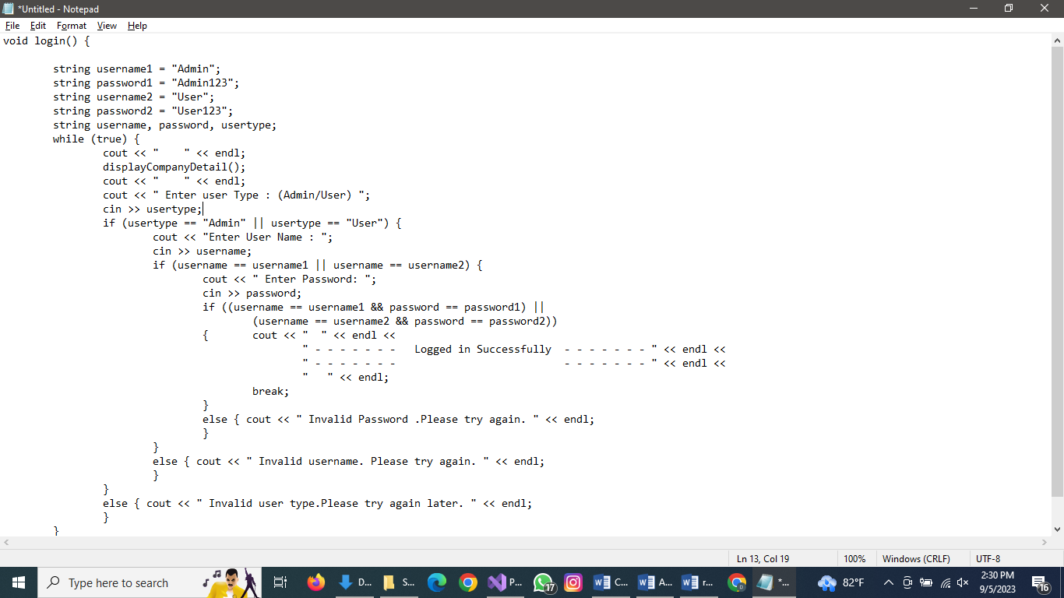

Output :

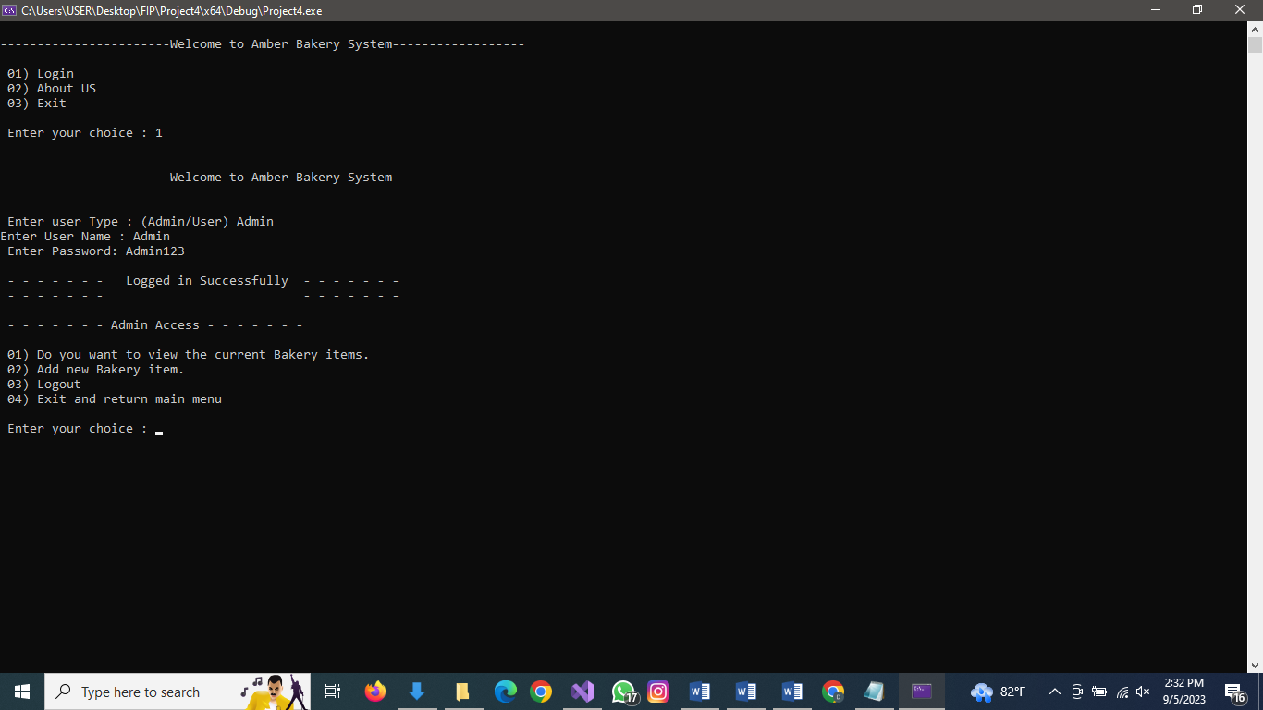

  - Void admindash()
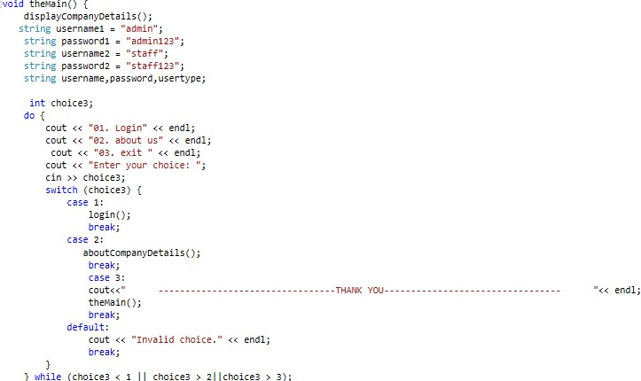
Once the login function grant access. The admin dashboard interface is displayed.

  - Void managebakeryitems()
This menu-driven functions enables the admin to manage bakery details. There are 4 options.

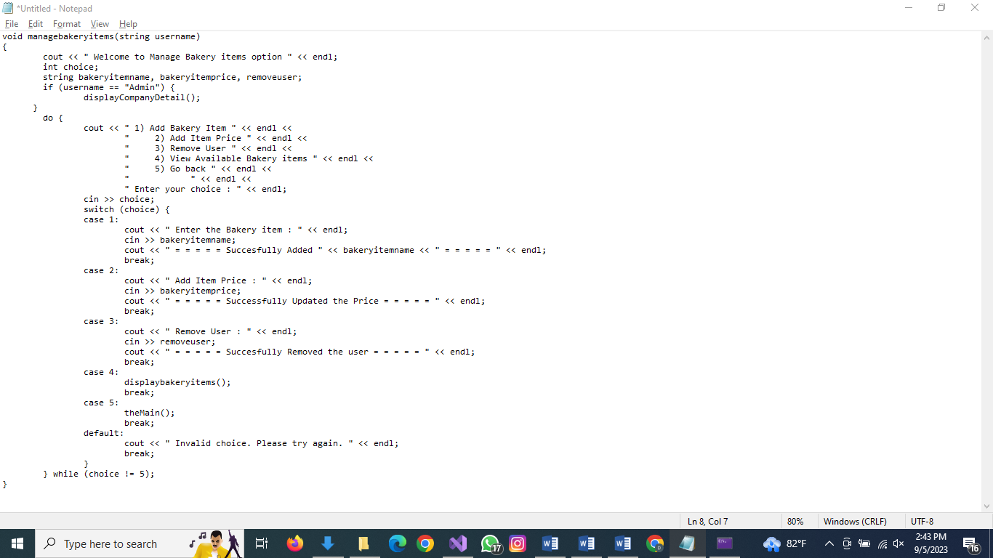

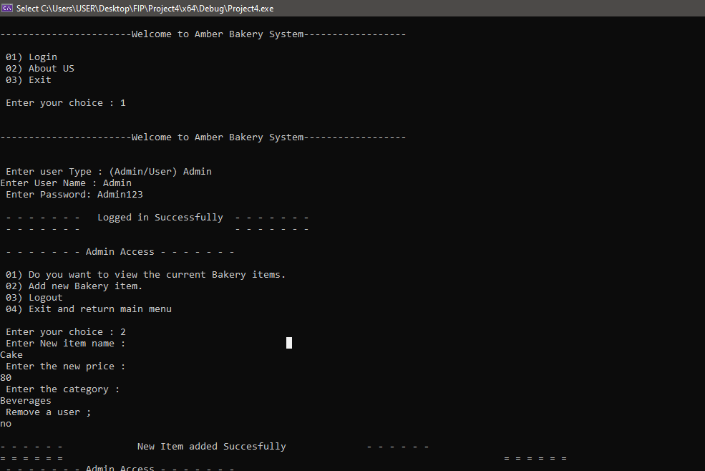

    - Void viewbakeryitem()

The details of each bakery item are from a item name and prices.

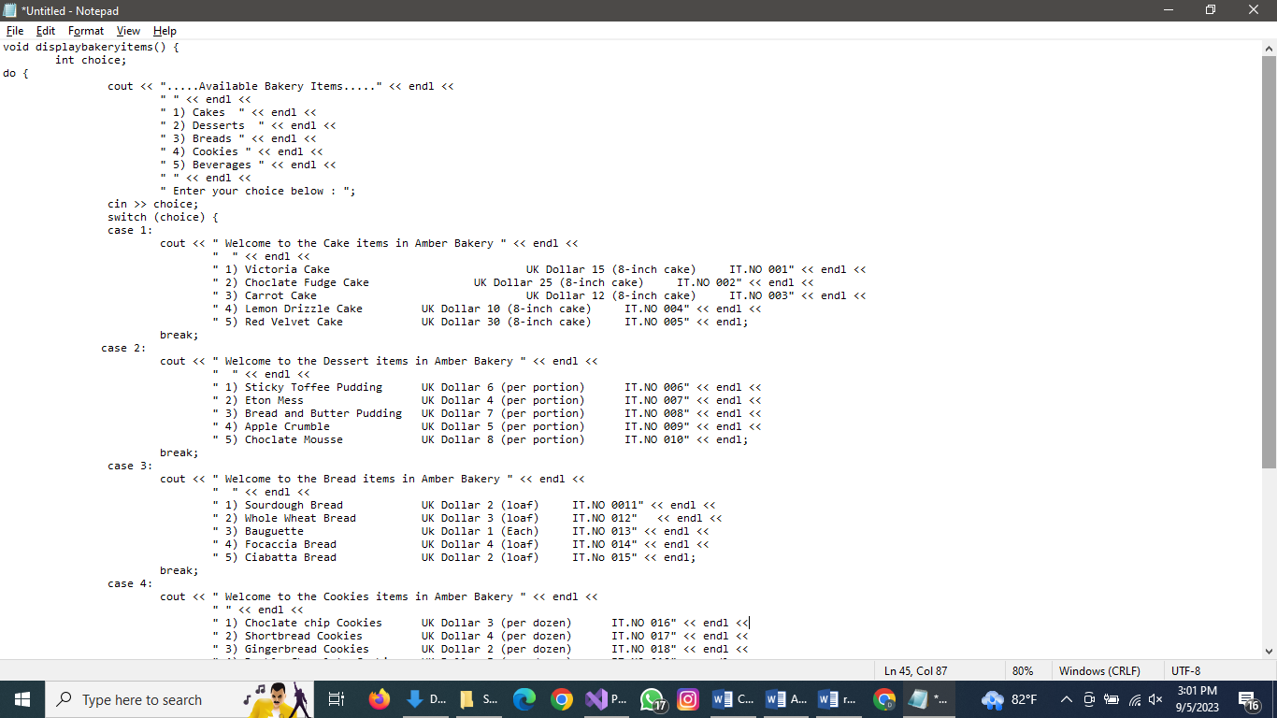

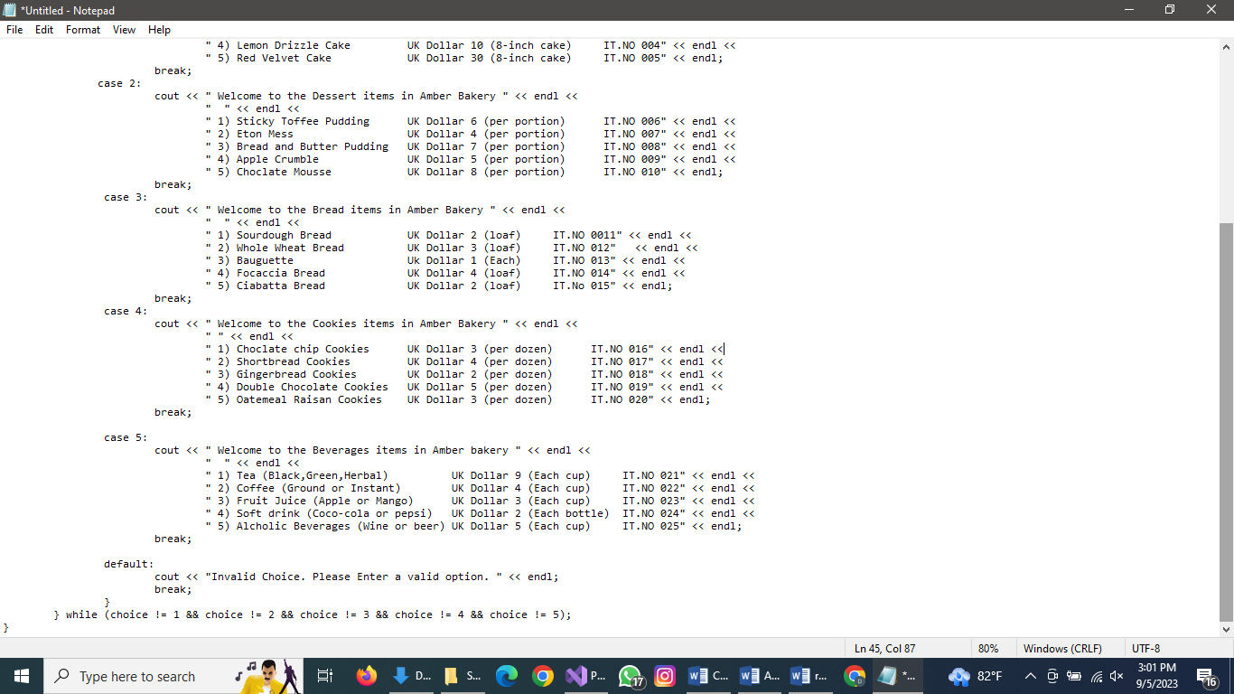
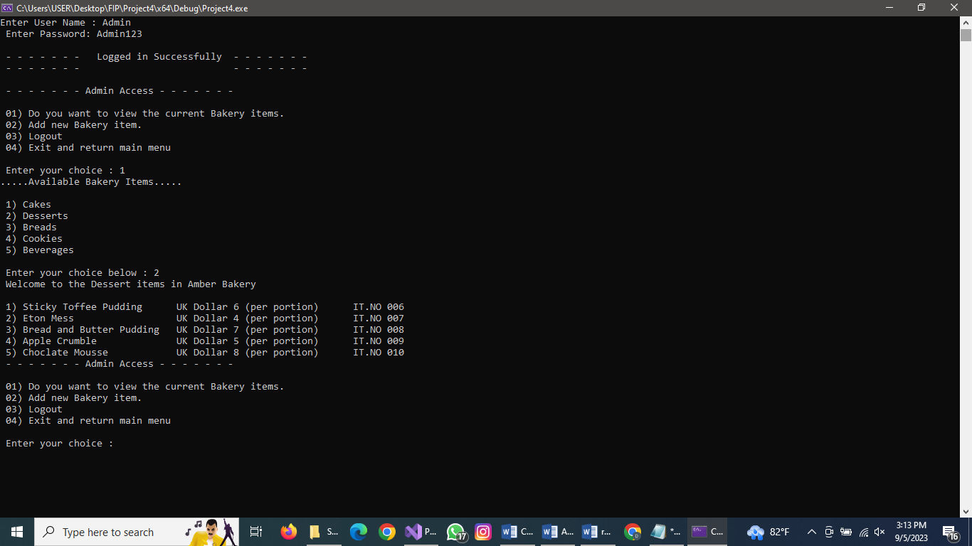

3.TEST PLAN AND USER ACCEPTABLE TESTING (TASK-3)
3.1
TEST CASE ID | TEST NAME | TEST STEPS | TEST DATA | ESTIMATED RESULTS
01 | Main page – Option 1  Login Dashboard | 1.Press 1 | Defendable Input | Login Dashboard
01 | Main page – Option 1  Login Dashboard | 2.Press Enter | Defendable Input | Login Dashboard
02 | Main page - Option 2 About Amber bakery | 1.Press 2 | Defendable Input | Display company details
02 | Main page - Option 2 About Amber bakery | 2.Press Enter | Defendable Input | Display company details
03 | Main page - Option 3 Exit System | 1.Press 3 | Defendable Input | Exiting the program
03 | Main page - Option 3 Exit System | 2.Press Enter | Defendable Input | Exiting the program
04 | Main page - Wrong Option | 1. Entered the wrong option | Invalid Input | Invalid Notification and Again Displaying
04 | Main page - Wrong Option | 2.Press Enter | Defendable Input | Invalid Notification and Again Displaying
05 | Verify Login Credentials - Option 1 | Enter the Usertype admin | Defendable Input | Username password interface
05 | Verify Login Credentials - Option 1 | Enter the Usertype staff | Defendable Input | Username password interface
06 | Verify Login Credentials - Option 1 | Enter the admin username | Defendable Input | Login successful Notification and displaying
06 | Verify Login Credentials - Option 1 | Enter the staff username | Defendable Input | Login successful Notification and displaying
07 | Verify Login Credentials - Option 1 | Enter the admin username | Defendable Input | Display invalid username or password
07 | Verify Login Credentials - Option 1 | Enter the admin password | Invalid Input | Display invalid username or password
08 | Verify Login Credentials - Option 1 | Enter the staff username | Defendable Input | Display invalid username or password
08 | Verify Login Credentials - Option 1 | Enter the staff password | Invalid Input | Display invalid username or password

09 | About Amber Bakery - Option 2 | Press Enter | Defendable Input | Display the company details
10 | Exit System - Option 3 | - | - | Exiting Notification
10 | Exit System - Option 3 | - | - | Exiting Notification
11 | Admin dashboard - Option 1 (View available items) | 1.Press 1 | Defendable Input | Display company details
11 | Admin dashboard - Option 1 (View available items) | 2.Press Enter | Defendable Input | Display company details
12 | Admin dashboard - Option 2 (add staff) | 1.Press 2 | Defendable Input | Displaying add staff details
12 | Admin dashboard - Option 2 (add staff) | 2.Press Enter | Defendable Input | Displaying add staff details
13 | Admin dashboard - Option 3 (add student) | 1.Press 3 | Defendable Input | Displaying add student details
13 | Admin dashboard - Option 3 (add student) | 2.Press Enter | Defendable Input | Displaying add student details
14 | Admin dashboard - Option 4  (manage course details) | 1.Press 4 | Defendable Input | Displaying manage bakery details
14 | Admin dashboard - Option 4  (manage course details) | 2.Press Enter | Defendable Input | Displaying manage bakery details
15 | Admin dashboard - Option 5 (logout) | 1.Press 5 | Defendable Input | Logout successfully notification
15 | Admin dashboard - Option 5 (logout) | 2.Press Enter | Defendable Input | Logout successfully notification
16 | Admin dashboard – Main menu | 1.press 6 | Defendable Input | Display main menu
16 | Admin dashboard – Main menu | 2.Press Enter | Defendable Input | Display main menu
17 | Admin dashboard – invalid option | 1.Enter the wrong option | Invalid Input | Invalid choice and return to admin dashboard
17 | Admin dashboard – invalid option | 2.Press Enter | Defendable Input | Invalid choice and return to admin dashboard

18 | Staff dashboard  - Option 1 (View available courses) | 1.Press 1 | Defendable Input | Display company details
18 | Staff dashboard  - Option 1 (View available courses) | 2.Press Enter | Defendable Input | Display company details
19 | Staff dashboard - Option 2 (add student) | 1.Press 2 | Defendable Input | Displaying add student details
19 | Staff dashboard - Option 2 (add student) | 2.Press Enter | Defendable Input | Displaying add student details
20 | Staff dashboard  - Option 3 (logout) | 1.Press 3 | Defendable Input | Logout successfully notification
20 | Staff dashboard  - Option 3 (logout) | 2.Press Enter | Defendable Input | Logout successfully notification
21 | Staff dashboard  – Main menu | 1.press 4 | Defendable Input | Display main menu
21 | Staff dashboard  – Main menu | 2.Press Enter | Defendable Input | Display main menu
22 | Staff dashboard  – invalid option | 1.Enter the wrong option | Invalid Input | Invalid choice and return to admin dashboard
22 | Staff dashboard  – invalid option | 2.Press Enter | Defendable Input | Invalid choice and return to admin dashboard

23 | Manage bakery details - Option 1 (Add course) | 1.Press 1 | Defendable Input | Display add bakery details
23 | Manage bakery details - Option 1 (Add course) | 2.Press Enter | Defendable Input | Display add bakery details
24 | Manage course details - Option 2 (remove course) | 1.Press 2 | Defendable Input | Display remove item details
24 | Manage course details - Option 2 (remove course) | 2.Press Enter | Defendable Input | Display remove item details
25 | Manage course details - Option 3 (view course) | 1.Press 3 | Defendable Input | Display view  bakery details
25 | Manage course details - Option 3 (view course) | 2.Press Enter | Defendable Input | Display view  bakery details
26 | Staff dashboard  – Main menu | 1.press 4 | Defendable Input | Display main menu
26 | Staff dashboard  – Main menu | 2.Press Enter | Defendable Input | Display main menu
27 | Staff dashboard  – invalid option | 1.Enter the wrong option | Invalid Input | Invalid choice and return to admin dashboard
27 | Staff dashboard  – invalid option | 2.Press Enter | Defendable Input | Invalid choice and return to admin dashboard

Test Case ID | 01
Test Name | Main menu - Option 1 Login Interface
Test steps | - Press 1  - Press Enter
Estimated results | Login Interface
Actual results | Same as Estimated results
Screenshot | 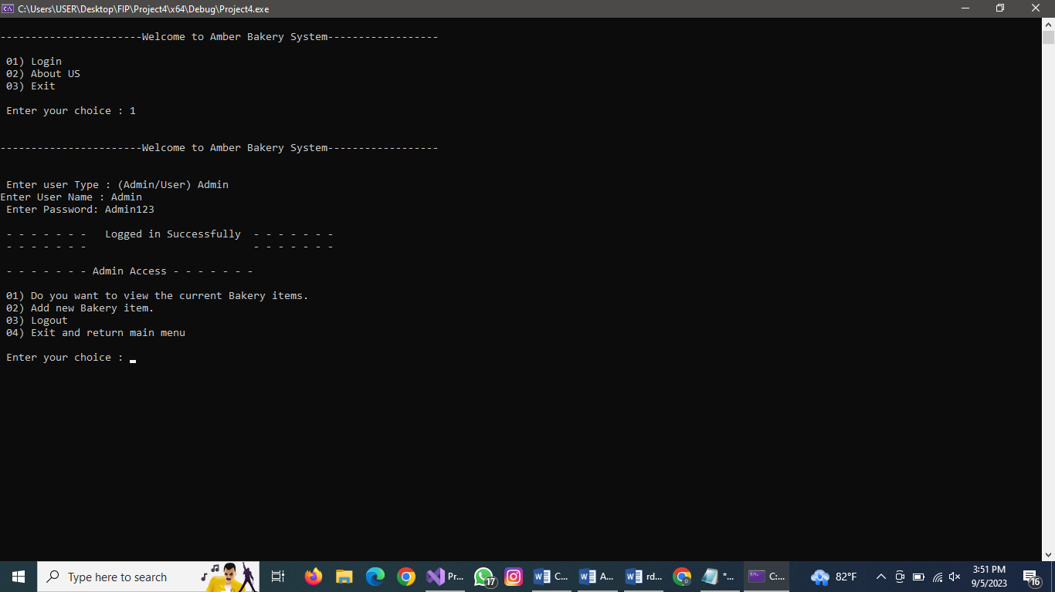
Conclusion | Test Pass
3.2 Test Cases

Test Case ID | 02
Test Name | Main menu - Option 2 about master mind institute
Test steps | - Press 2  - Press Enter
Estimated results | Displaying company details
Actual results | Same as Estimated results
Screenshot | 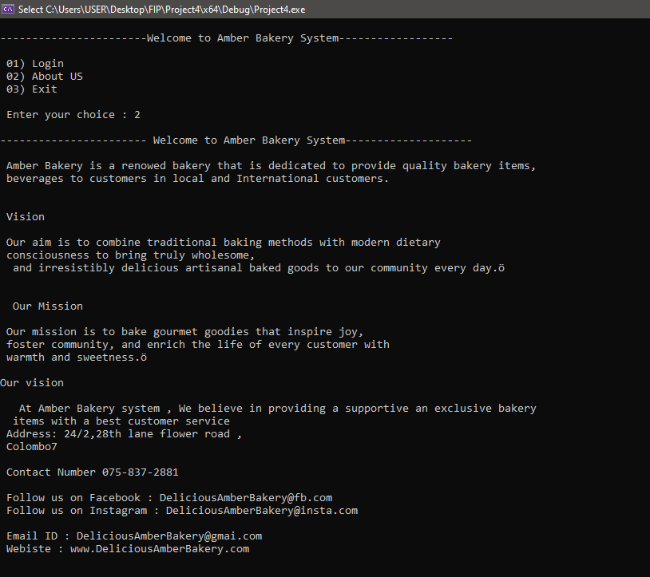
Conclusion | Test Pass

Test Case ID | 03
Test Name | Main menu - Option 3 Exit
Test steps | - Press 3  - Press Enter
Estimated results | Exiting program
Actual results | Same as Estimated results
Screenshot | 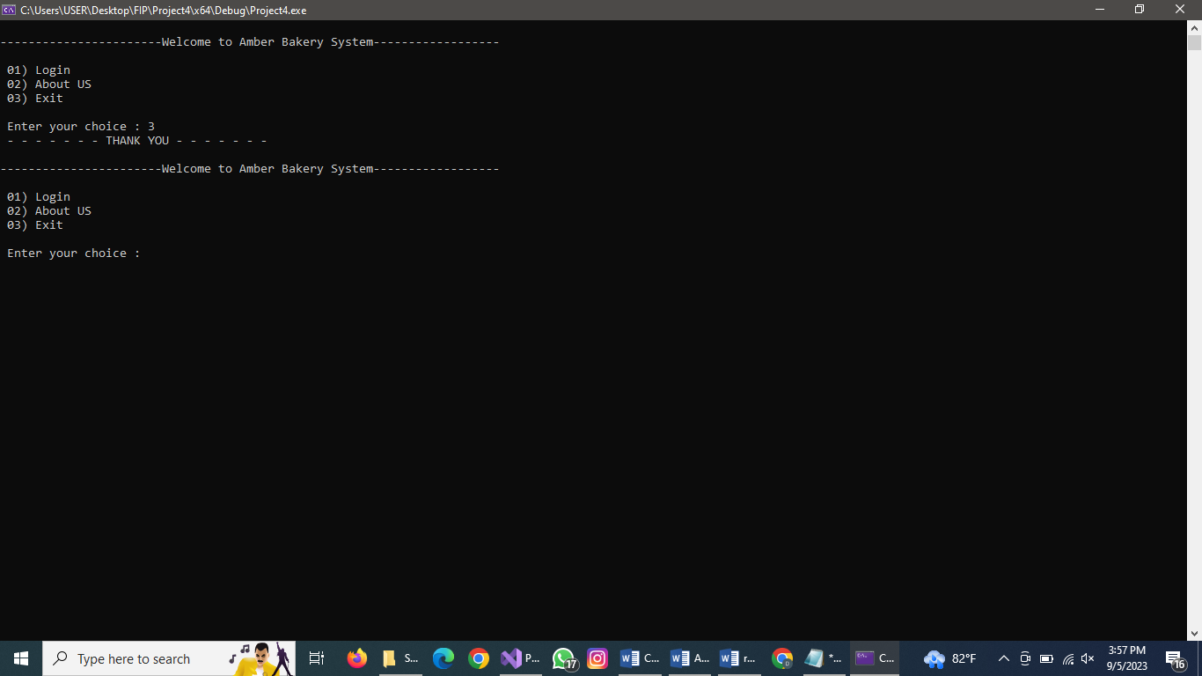
Conclusion | Test Pass

Test Case ID | 04
Test Name | Verify Login Credentials - Option 1
Test steps | Enter user type(admin)
Estimated results | Selected user interface
Actual  Results | Same as Estimated results
Screenshot | 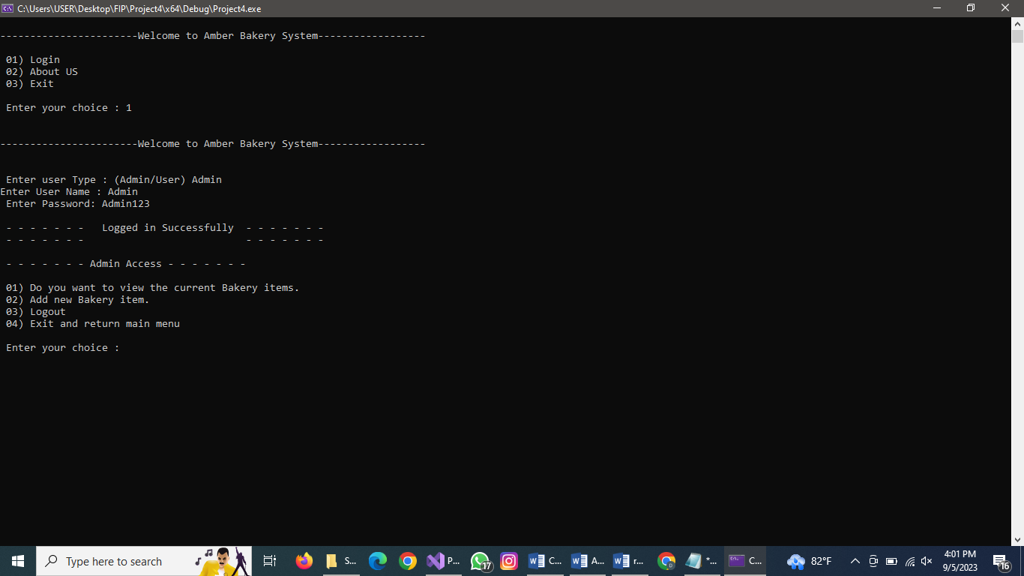
Conclusion | Test Pass
Test Case ID | 05
Test Name | Verify Login Credentials - Option 1
Test steps | Enter user type(staff)
Estimated  Results | Selected user interface
Actual results | Same as Estimated results
Screenshot | 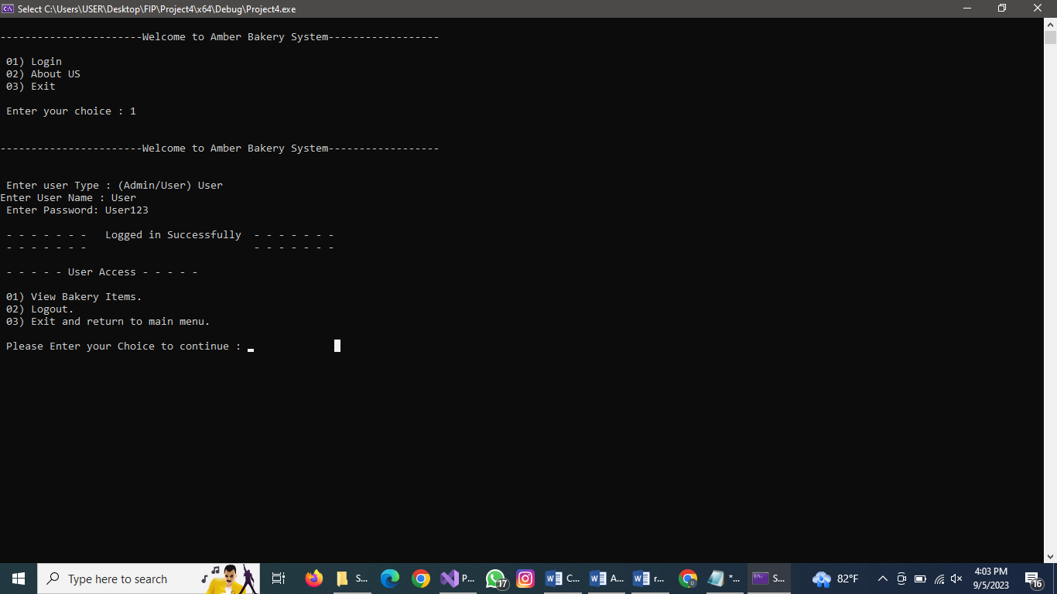
Conclusion | Test Pass

Test Case ID | 06
Test Name | About Master Mind Institute - Option 2
Test steps | - Press 2  - Press Enter
Estimated results | About Amber bakery
Actual  Results | Same as Estimated results
Screenshot
Conclusion | Test Pass
Test Case ID | 07
Test Name | Exit System - Option 3
Test steps | - Press 3  - Press Enter
Estimated results | Exiting program
Actual  results | Same as Estimated results
Screenshot
Conclusion | Test Pass

Test Case ID | 07
Test Name | Manage bakery details - Option 2 (Add new item)
Test steps | 1.Press 5 2.Press Enter
Estimated results | Displaying add bakery details
Actual  results | Same as Estimated results
Screenshot | 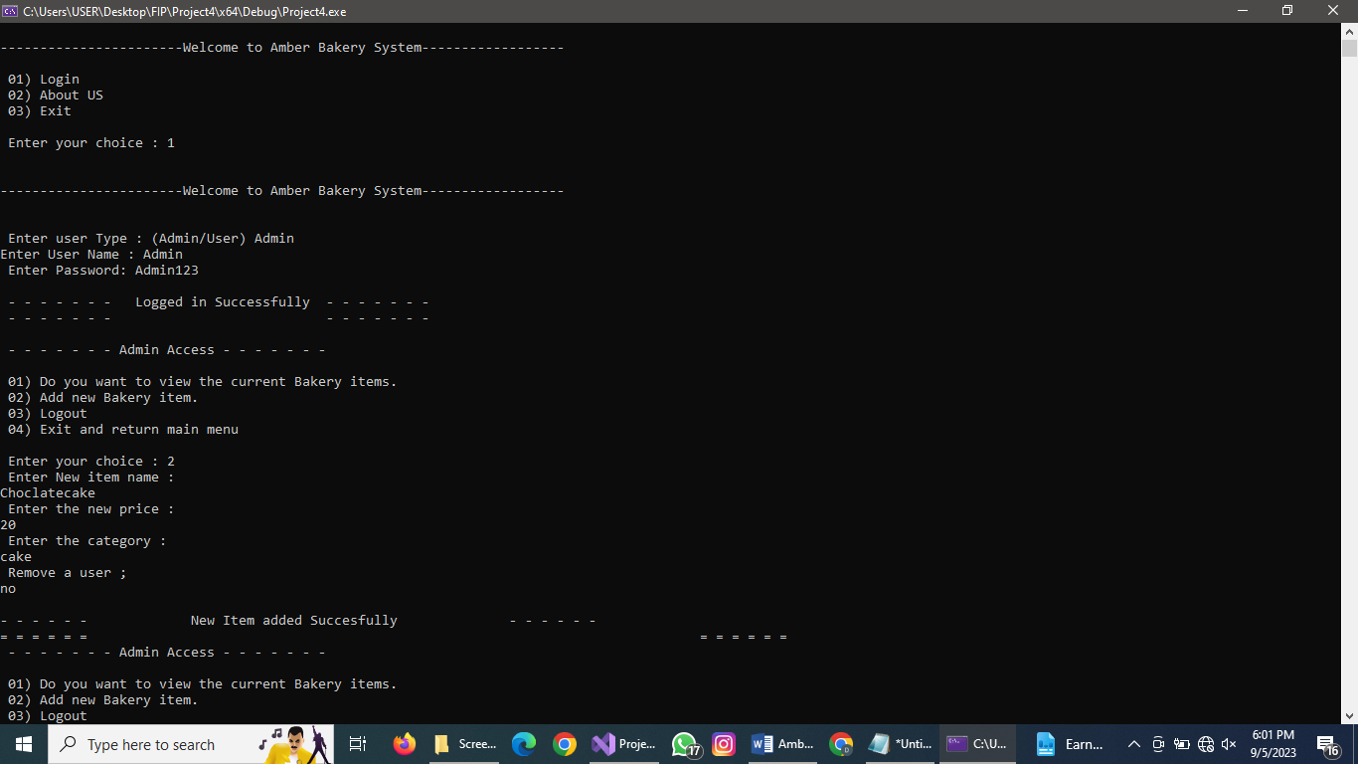
Conclusion | Test Pass

Test Case ID | 08
Test Name | Manage bakery details - Option 1(view items)
Test steps | 1.Press 1 2.Press Enter
Estimated results | Displaying course details
Actual  results | Same as Estimated results
Screenshot | 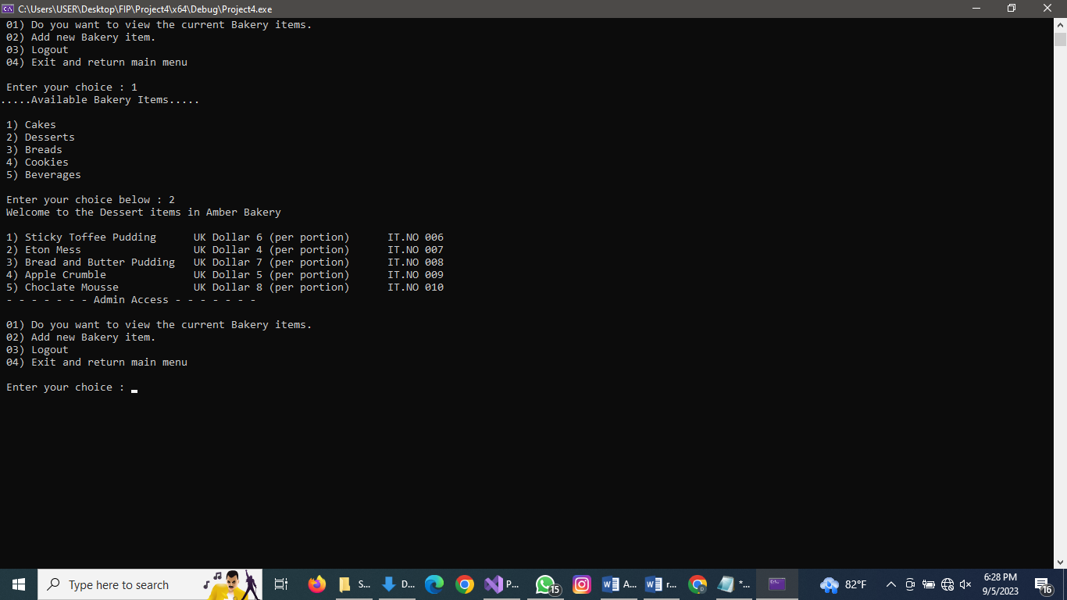
Conclusion | Test Pass
Test Case ID | 09
Test Name | Manage bakery details - Option 4 (go back)
Test steps | 1.Press 4 2.Press Enter
Estimated  results | Exiting
Actual results | Same as Estimated results
Screenshot | 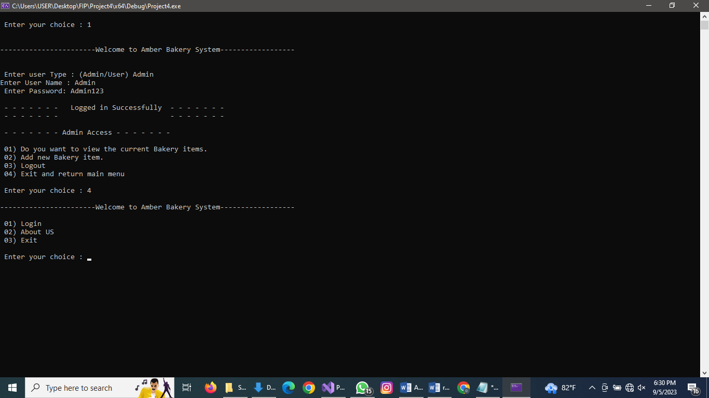
Conclusion | Test Pass

4.Suggestion

Text file data storage can be helpful for minor applications, but it might be slow and ineffective for more complex ones. Instead , keep track of staff and bakery information in a database.
Another recommendation would be to use variable names that are clear and more specific. For instance , you could change the names of the variables in the admin struct and staff struct.

5.Conclusion

C++ has been used to implement the suggested fix for the Amber bakery’s work overload issue. In addition to managing bakery items and staff registration, this program also provides user login, bakery information and exit.
To reduce complexity and improve coding speed, the software was created with the help of modularization strategies and concepts from structured programming.

6.References

C++ introduction (no date) Tutorials. Available at: https://www.w3schools.com/cpp/cpp_intro.asp (Accessed: 02 September 2023).

(No date) (PDF) an overview of the C++ programming language - researchgate. Available at: https://www.researchgate.net/publication/2334185_An_Overview_of_the_C_Programming_Language (Accessed: 06 September 2023).

